

| **Title: Design of Test Cases** |
| --- |

**______________________________________________________________________**

**Expected Outcome of Experiment:**

**CO2: Implement and prototype creation for the specified application.**

**_________________________________________________________________**

**Books/ Journals/ Websites referred:**

*[Students can mention websites/ books used in their project implementation]*

**______________________________________________________________________**

**This write up will expect students to prepare chapter no. 4 in the format given below**

**Chapter 4**

**Design Test Cases**



**Introduction:**

Developing design test cases is crucial for identifying defects early, ensuring software quality, and validating user requirements, ultimately leading to a more reliable and user-friendly product.

Testing of a software system is a very essential step which provides benefits such as:

* Early Defect Detection:

Thoroughly designed test cases help uncover defects early in the development lifecycle, minimizing costly rework and delays.

* Enhanced Software Quality:

By systematically testing all features and functionalities, test cases ensure that the software meets user expectations and performs as intended.

* Improved User Satisfaction:

A well-tested product with fewer bugs leads to a better user experience and increased satisfaction.

* Reduced Costs:

Identifying and fixing defects early in the development process is significantly cheaper than fixing them later, saving time and resources.

* Validation of Requirements:

Test cases verify that the software meets the defined requirements and functionalities, ensuring that the product delivers on its promises.

* Increased Confidence:

Thorough testing builds confidence among stakeholders, including customers, investors, and regulatory bodies, regarding the software's quality and reliability.

* Optimized Testing Effort:

Well-designed test cases ensure comprehensive test coverage, minimizing redundancy and maximizing efficiency.

* Facilitates Bug Detection:

Test cases help identify when something in the software isn't working correctly, allowing bugs to be fixed before the software is released.

* Ensures Coverage:

They help to ensure that every feature of the software is tested and that all the requirements are covered.

* Traceability:

Test cases can be traced back to the requirements they are testing, providing a clear link between the requirements and the testing process.

* Test Scenarios:

Test scenarios are useful for organizing your test cases and providing high-level information on what to test in your application.

* Test Coverage:

Test coverage reports on areas of the codebase that are not covered by the test cases, facilitating the creation of new test cases to ensure maximum test coverage.

Students will be required to perform tests (whichever are applicable) from the below list:

1. Validation of data:

Checking if the entered values are in the correct format and within the range etc.

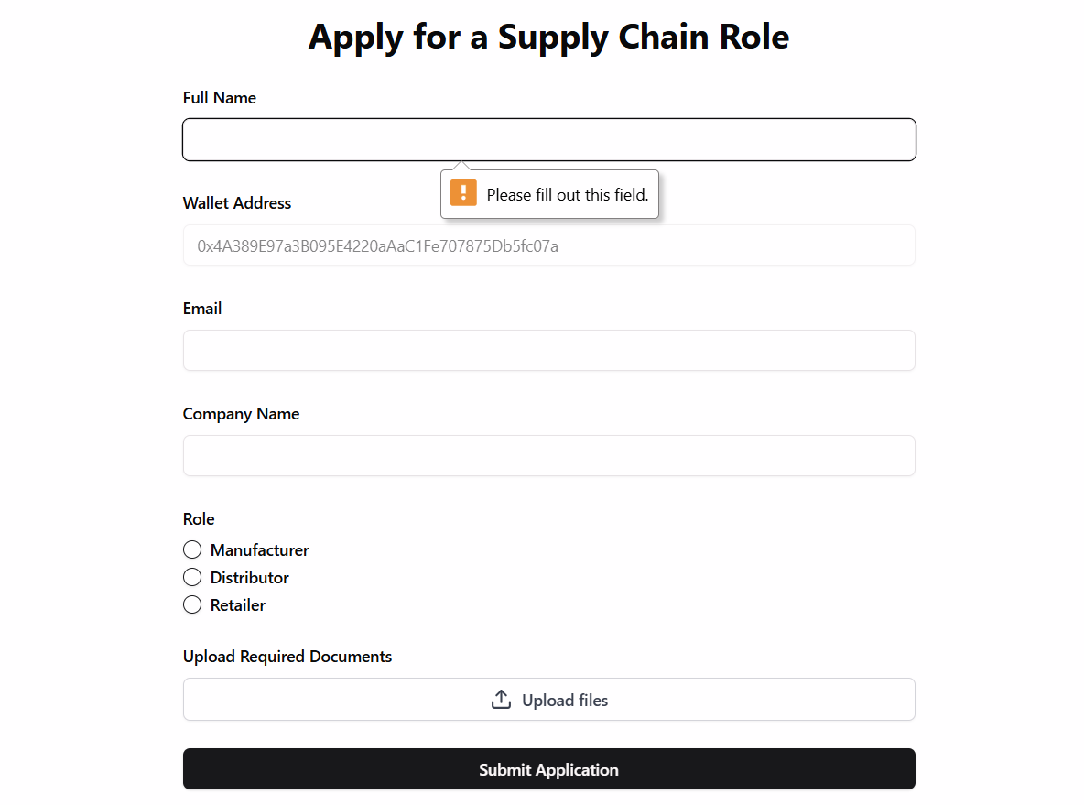

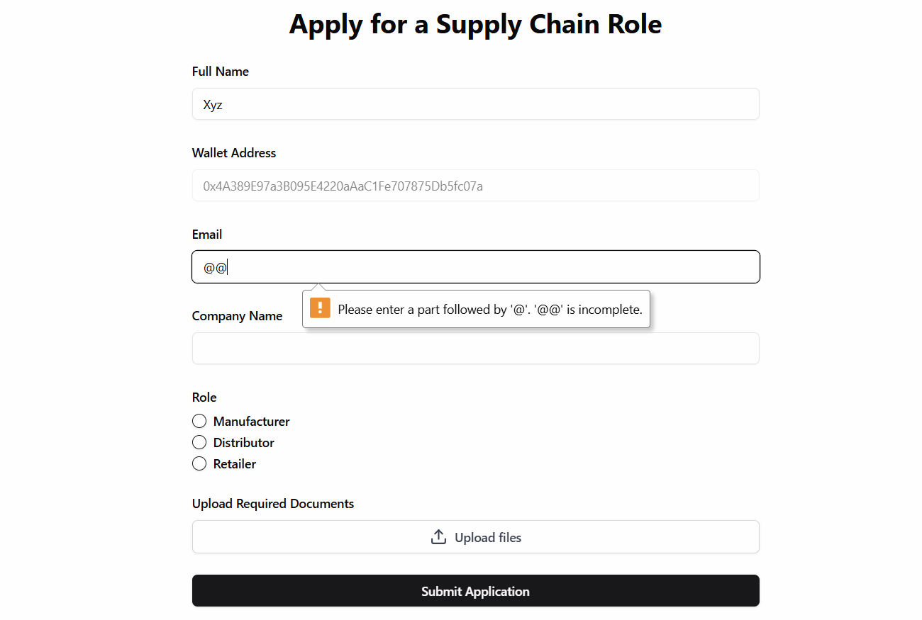

1. Appropriate Navigation

Accessing the various pages as per the flow of the system

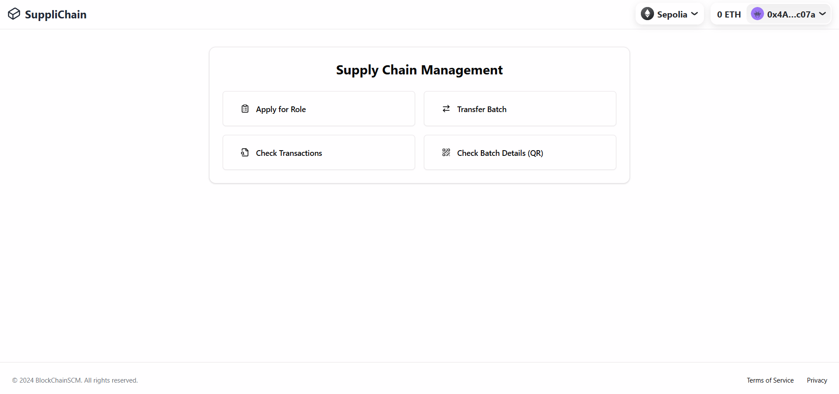

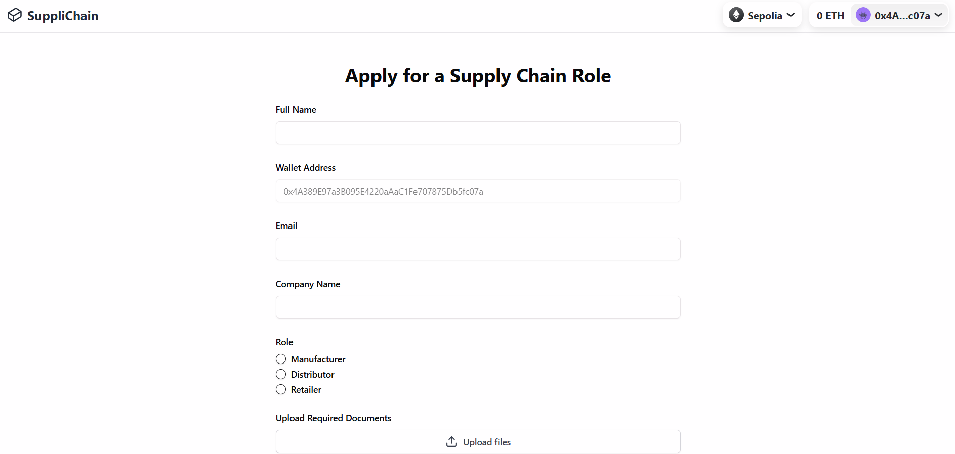

1. Verification of the results generated using the system.

Check if the results are correct

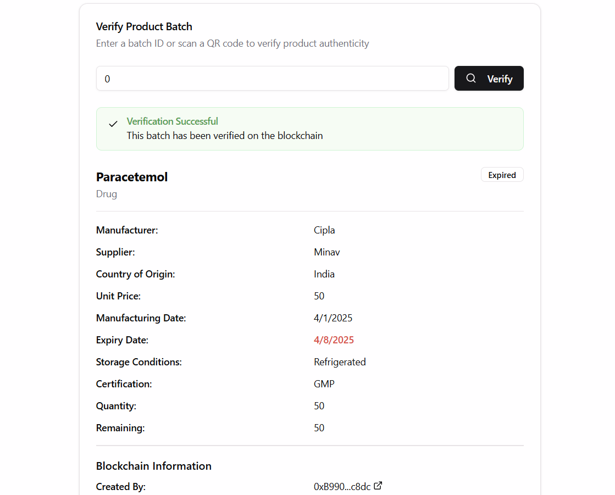

**Conclusion:**

​After conducting comprehensive testing, all mentioned test cases have passed successfully. This outcome confirms that the system's data validation processes, navigation functionality, and result verification mechanisms are operating as intended. Consequently, the system is deemed ready for deployment, ensuring users can interact with it seamlessly and rely on its accurate outputs.